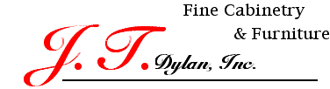

Thank you for your interest in our company and our cabinetry.

Below you will find a list of our standard cabinetry specifications. Please be aware that these specifications are considered to be an upgrade by many other cabinetry manufacturers. Keep this in mind when comparing prices.

We look forward to working with you in the future.

Standard Cabinet Specifications:
- ¾” Maple Veneer Core Plywood Sides, Bottom, Top, and Shelves
- ½” Maple Veneer Core Plywood Backs
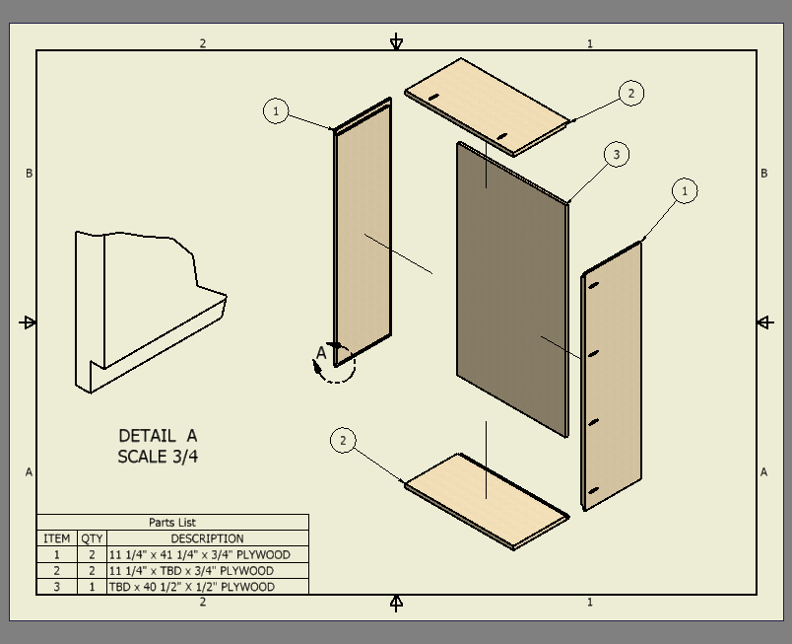
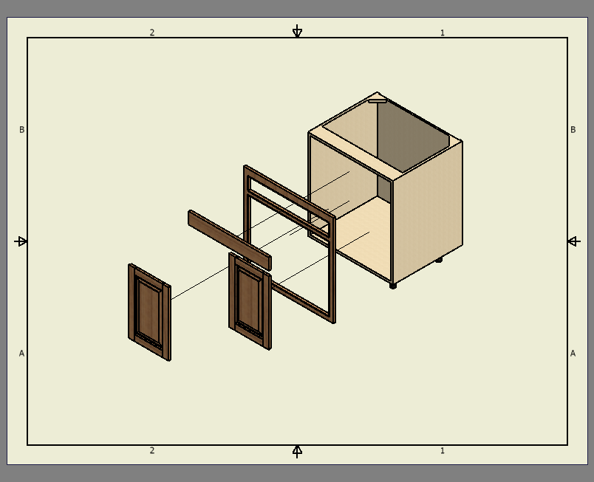
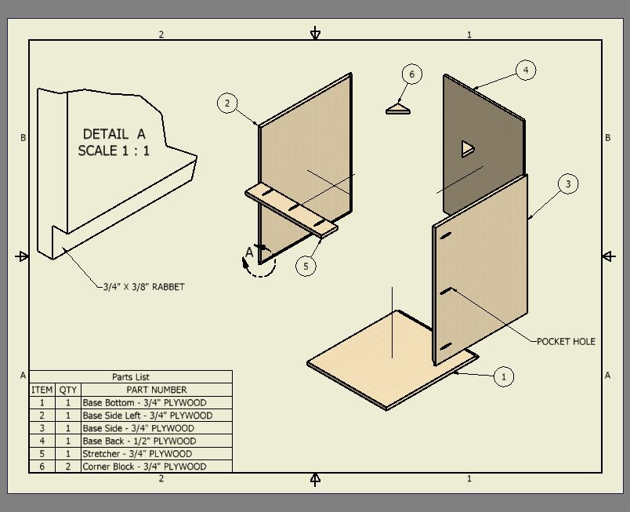
- Full Rabbet Carcass Construction
Exploded View of Wall Cabinet
Exploded View of Cabinet Assembly
Exploded View of Base Cabinet
- 3 Piece Leveling Legs for Base Cabinets
- Traditional Face Frame Construction
- Inset Mounted Doors
- Gras 3000 self-closing concealed hinge
- Hard Maple Dovetailed Drawer Boxes
- KV9500 concealed under-mount self-closing drawer slides

